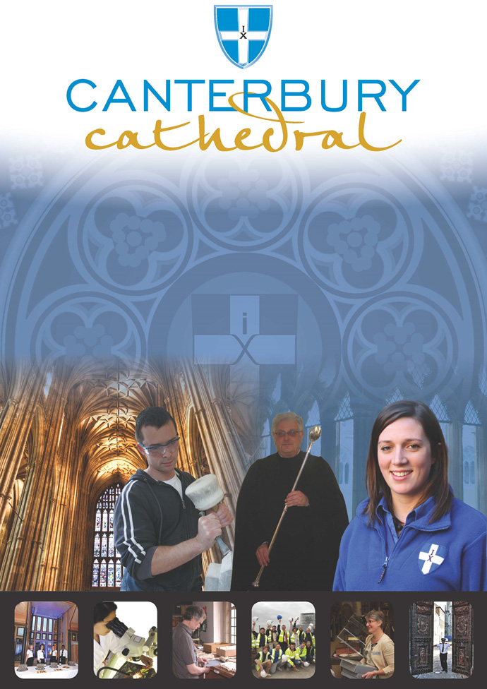

PROFILE OF CANTERBURY CATHEDRAL
St Augustine, the first Archbishop of Canterbury, arrived on the coast of Kent as a missionary to England in 597 AD. He came from Rome, sent by Pope Gregory the Great. It is said that Gregory had been struck by the beauty of Angle slaves he saw for sale in the city market and dispatched Augustine and some monks to convert them to Christianity. Augustine was given a church at Canterbury (St Martin’s, after St Martin of Tours, still standing today) by the local King, Ethelbert whose Queen, Bertha, a French Princess, was already a Christian. This building had been a place of worship during the Roman occupation of Britain and is the oldest church in England still in use. Augustine had been consecrated a bishop in France and was later made an archbishop by the Pope. He established his seat within the Roman city walls (the word cathedral is derived from the Latin word for a chair ‘cathedra’, which is itself taken from the Greek ‘kathedra’ meaning seat.) and built the first cathedral there, becoming the first Archbishop of Canterbury. Since that time, there has been a community around the Cathedral offering daily prayer to God; this community is arguably the oldest organisation in the English speaking world. The present Archbishop, The Most Revd Justin Welby, is 105th in the line of succession from Augustine.
Augustine’s original building lies beneath the floor of the nave– it was extensively rebuilt and enlarged by the Saxons, and the Cathedral was rebuilt completely by the Normans in 1070 following a major fire. There have been many additions to the building over the last nine hundred years, but parts of the quire and some of the windows and their stained glass date from the 12th century.
By 1077, Archbishop Lanfranc had rebuilt it as a Norman church, described as “nearly perfect”. A staircase and parts of the North Wall – in the area of the North West transept also called the Martyrdom – remain from that building.
During the Second World War, the Precincts were heavily damaged by enemy action and the Cathedral’s Library was destroyed. Thankfully, the Cathedral itself was not seriously harmed, due to the bravery of the team of fire watchers, who patrolled the roofs and dealt with the incendiary bombs dropped by enemy bombers.
Today, the Cathedral stands as a place where prayer to God has been offered daily for over 1,400 years; nearly 2,000 services are held each year, as well as countless private prayers from individuals. The Cathedral offers a warm welcome to all visitors – its aim is to show people Jesus, which we do through the splendour of the building as well as the beauty of the worship.

THE WORK OF THE CATHEDRAL
The work of the Cathedral is carried out by over 300 paid staff, supported by some 500 volunteers. The ‘corporate body’ responsible for the management of the Cathedral is the Chapter of Canterbury who are advised by the Cathedral Council and the College of Canons.

The Chapter of Canterbury (Chapter)
The Chapter are responsible for all aspects of the day-to-day management of the Cathedral. Chapter comprises the Dean, the Residentiary Canons, the Receiver General and four additional persons appointed by the Archbishop.

The Cathedral Council
The Council represents the Cathedral community as well as the wider local and regional community. It has 20 members, drawn from a wide variety of organisations. Its duty is to further and support the work of the Cathedral Church in spiritual, pastoral, evangelistic, social and ecumenical areas.

The College of Canons
The College of Canons is composed of 30 Honorary, Lay and Provincial Canons, appointed by the Archbishop and it supports the life of the Cathedral in many different ways.

The Cathedral Trust
The Cathedral Trust is a separate charity that is solely for the benefit of the Cathedral. Since 1974, it has assisted with the restoration, maintenance and improvement of the fabric and contents of Canterbury Cathedral and the provision, promotion and encouragement of music.
The Cathedral is well-known all over the world and we welcome more than 1 million visitors and worshippers every year. The Cathedral is more than just a beautiful old building and heritage site; it is a working, living church which maintains a tradition of welcome and worship that has been practised here for over 1400 years.

Friends
The Friends of Canterbury Cathedral was founded in 1927 by the distinguished scholar and poet Dean George Allen Kennedy Bell. The Organisation was the first of its kind in the world.
The Friends are the Cathedral’s fan club. Admirers of the building, its history and its community, Friends are a part of the Cathedral and work together to preserve it forever, contributing financially - and directly – to many individual and vital projects.

The Cathedral Shop
The Canterbury Cathedral Shop is a large gift shop in the heart of the city of Canterbury. It has an impressive range of high quality gifts, mostly British, and their own exclusive award winning designs.
The Shop’s wide range of merchandise includes replica historical artefacts, books and CDs of the world-famous Canterbury Cathedral choir.

Music & Liturgy Department
Organist and Master of the Choristers
Choristers
Mistress of the Robes
Minibus Drivers
Lay Clerks
Second Assistant Organist
Assistant Organist and Director of the Cathedral Girls’ Choir
Music & Liturgy Secretary
Music & Liturgy Administrators
Cathedral Choir Administrator

Precentor

Chorister Chaperones

JOB PROFILE
Lay Clerks report directly to the Organist and Master of the Choristers and in his absence to the Assistant Organist.

PRINCIPAL TASKS
- To sing at services to the required standard as requested by the Master of the Choristers.
- As an employee of the Chapter of Canterbury to fully endorse, understand and exercise the roles and responsibilities contained within the Chapter’s Health and Safety policy which is set out in the Staff Handbook.
- To carry out any other reasonable task as requested by the Organist and Master of the Choristers or Chapter.

PERSONAL SPECIFICATION
The personal specification below indicates the qualifications, experience, knowledge and skills required to undertake the role effectively.

ESSENTIAL KNOWLEDGE AND SKILLS
- Experience as a professional musician.

- Experience in Anglican service music, including psalm singing.

- Experience in a similar role.

- An understanding of and sympathy with the aims and purposes of the Cathedral, its worship, mission and ministry.

DESIRABLE KNOWLEDGE AND SKILLS
- Graduate status.

PERSONAL ATTRIBUTES
- An excellent vocal ability and musicianship.
- Confident.
- Organised and self-disciplined.
- A flexible approach to hours worked.
- A practising communicant within the Anglican Communion. (desirable)

TERMS AND CONDITIONS

Salary
£ 13,050 per annum, Extra fees are payable for broadcasts, recordings etc, and for some
non-statutory services.

Working hours
Lay Clerks are required to sing as follows:

Services:

Sunday Eucharist and Sunday Evensong

Evensong on each weekday except Thursday, which normally will be a day off. There will be a sung Eucharist on Ascension Day, a Thursday, for which a day off will be given in lieu.

Evensong may be replaced with a Sung Eucharist on Principal Feasts. (Epiphany, Candlemas, The Annunciation, All Saints Day) and All Souls Day (a Requiem Eucharist). A sung Eucharist also replaces Evensong on Corpus Christi, which is always celebrated on a Thursday but this is boys voices only or sung by a visiting choir. A list is provided by the Organist at the beginning of each term to confirm these dates.

Three services on Christmas Day, Easter Day and Pentecost.

Two Services on Good Friday

An Epiphany Carol service on the Sunday after the Epiphany, in place of Evensong.

The Christmas Carol Services; the Remembrance Sunday Service; Evensong on 29th December; an extra evening service on days in Holy Week and the Vigil on Holy Saturday. These services each attracting an extra fee, the Vigil to count as double. Attendance at these services is strongly encouraged.
Absences:
A Lay Clerk is required to attend all services and rehearsals as detailed, Absence from these for external engagements is by prior arrangement with the Organist and must be kept to a minimum. A service fee is deducted for absences. Under normal circumstances, only 2 lay clerk absences per voice part for any service will be allowed. A third request may be denied. Requests will be agreed on a ‘first come first served’ basis.
Rehearsals:

Tuesday : 1 hour (normally 18.15 to 19.15 hrs) This is being trialled in 2018, with a review due in November.
Monday )
Tuesday ) 15 minutes before Evensong
Friday )
Wednesday: 25 minutes before Evensong
Saturday: 45 minutes before Evensong
Sunday: 35 minutes before Eucharist , 15 minutes before Evensong

Other Work:

It is hoped that a Lay Clerk will find supplementary work in the local area and the Organist
will give as much assistance as he can in this respect. The choir undertakes outside
engagements, tours and recordings from time to time.

Annual holiday
All Lay Clerks are entitled to holidays as a group.
The Organist will give at least 9 months’ notice of the exact dates:

- At least 38 days in Summer or early Autumn.
- 11 consecutive days after Christmas, with the exception of 29th December.
- 12 consecutive days after Easter (including one weekend), except on the rare occasions when Easter falls very late, when the holiday will be split before Palm Sunday and after Easter Day.

Workwear
Lay Clerks are expected to provide and wear black shoes at every service.
Chapter will provide a cassock and surplice. Hoods should only be worn on
Festivals and those occasions stipulated by Chapter.

Accommodation
It is hoped that a suitable flat or place in a shared house will be available for a Lay Clerk who
requires it. Rent and other charges are the tenant’s responsibility.

Training
Training needs, vocal ability and musicianship are assessed continuously and will be formally reviewed through the Cathedral’s annual appraisal process Singing lessons and other training are provided.

Probation Period
All new posts are subject to a probation period. New staff will meet regularly with their line manager to assess both formally and informally progress on work and performance.

Pension scheme
The Chapter of Canterbury offer a Stakeholder pension to all employees. Your age and salary will determine if you are to be automatically enrolled into the pension scheme. Chapter contribute 7½ % of salary into a Stakeholder Pension Scheme. Staff in the pension scheme are insured against death in service 3 x annual salary to the age of 70.

Staff benefits
We are able to offer a range of staff benefits including discounts in local shops, restaurants and sports centres.

Parking
Lay Clerks are entitled to park their vehicles on site whilst discharging their responsibilities.

Additional Requirements
Before a formal offer of employment can be made, the applicant will be required to have:

A satisfactory disclosure from the Disclosure and Barring Service will be required upon employment. This position is exempt from the provision of Section 4(2) of the Rehabilitation of Offenders Act 1974 by virtue of the Rehabilitation of Offenders Act 1974 (Exceptions) Order 1975. The grounds on which it is exempt are that in the normal course of your duties you will have access to persons under the age of 18, and that your normal duties will be carried out wholly or partly on the same premises where the provision of training to persons under 18 takes place. Applicants are therefore not entitled to withhold information about convictions which for other purposes are “spent”. The DBS Code of Practice is available on request; alternatively you can obtain it from the DBS website www.gov.uk/dbs

EQUALITY STATEMENT
The Chapter of Canterbury recognises that discrimination and victimisation is unacceptable and that it is in the interests of the organisation and its employees to utilise the skills of the total workforce. It is the aim of the organisation is to ensure that no employee or job applicant receives less favourable facilities or treatment (either directly or indirectly) in recruitment or employment on grounds of age, disability, gender / gender reassignment, marriage / civil partnership, pregnancy / maternity, race, religion or belief, sex, or sexual orientation.
PERSONAL DATA
As your employer, the Chapter of Canterbury needs to keep and process information about you for normal employment purposes. The information we hold and process will be used for management and administrative use only. To comply with the General Data Protection Regulations, your acceptance of these terms and conditions gives your consent for your data to be processed.
This job description is provided to assist the post holder to know their principal duties. It may be amended from time to time in consultation with you, by, or on behalf of, the Head of the Department, without change to the level of responsibility appropriate to the grading of the post.

HOW TO APPLY

A CV should be submitted on line via our web page.

Application details can be found at:

http://canterbury-cathedral.org/get-involved/employment

The closing date for this post is: Sunday 20th October 2019
Auditions are expected to take place October / November 2019
The appointment will commence January 2020, or earlier by arrangement.

